

COURSEWORK 1 (ASSIGNMENT)

Programme
DIPLOMA IN COMPUTER SCIENCE
Subject Code  DDS1323 | Subject Name  PROGRAMMING FOR DATA SCIENCE
Study Period  JAN 2026 – MARCH 2026 | Deadline  13/03/26 (Week 6)

Student ID | Student Name

Course Learning Outcomes
CLO 2 | Explain code conventions, the OOP codes concepts, language idioms and professional programming practice. (C2, PLO2)
CLO 3 | Practice some of the more commonly used standard library functions using object-oriented solution for simple programming problem to reduce programming effort. (P3, PLO3)

SDS ACADEMIC INTEGRITY STATEMENT

Sunway Diploma Studies is committed to the principles of academic integrity. Academic integrity means placing five fundamental values: honesty, trust, fairness, respect, and responsibility into practice. It is being honest in the academic work you do at the programme/college, being fair to others, and taking responsibility for learning, and acting in an ethical manner in all your academic endeavours. We believe that these five values are truly foundational to the programme.

We hereby declare that:
- We fully understand and will uphold the academic integrity of Sunway Diploma Studies (SDS).
- We confirm that the work hereby submitted is our own original work and where other people’s work has been used this has been fully acknowledged.
- We are aware of the importance of conducting exams with integrity and fairness, and We hereby confirm that We will comply with the requirements.
- We are aware that non-compliance with these instructions and unfair conduct constitute a disciplinary offense, and actions will be taken including but not limited to being expelled.

No | Student Name | Signature | Date
1
2
3
4
5

Group Member Contribution Form

INSTRUCTION
This assignment will contribute 50% to your final grade.
This is a group assignment (ONLY THREE TO FOUR students in a group).

Please fill in the form completely and ensure all group members sign it. A deduction of 3 marks will be applied to the total marks if the group fails to comply with this requirement.

Student Name | Signature | Contribution (eg. Coding, Design, Testing, Documentation, Question 1, etc)
Example: JOHN |  | Example:  - Write coding for Data cleaning  - Write Coding for ETL  - Write Introduction in Report

ASSSIGNMENT QUESTION

The Assignment consist of TWO (2) phases which is Data Analysis Phase/ Data Mining (Refer Practical 6a) and Prediction Phase (Refer Practical 6b). Students are required to analyse the data and mine the data using the dataset. Students are required to select a business field or any organization which they are familiar with and are interested in. Next, you need to identify the use of data as an appropriate application of data analytics tools in the chosen organization.

For Data Analysis Phase / Data Mining, students are encouraged to conduct descriptive and other statistical data analysis using the data analysis tools taught in the class to evaluate and answer the relevant questions. The project should cover a wide range of contents discussed in the lecture. Students are required to explain each step of the Data Analysis Process below:
- Business understanding
- Data Preparation/ Data Understanding
- Data Exploration (EDA)
- Train and Test

For Prediction Phase, students are encouraged to apply the appropriate machine learning (data mining) algorithms which can be supervised learning models or unsupervised learning models using the data mining tools taught in the class to evaluate and answer the relevant questions. The project should cover a wide range of contents Prediction Phase steps discussed in the lecture such as below:
- Modelling
- Deployments

Students are required to submit a FULL report for these two (2) phases that outlines a strategic plan to perform data analysis, extraction, transform, modelling and prediction results. It includes the processes/pre-processing steps and utilize data available to help making better decisions. Student must prepare TWO different datasets with same column name.

Prepare a report according to the attached report format to assess and examine the following requirements/ sections:

Report Content
- Introduction
  - Write about Company history and background.
  - Nature of business / size of business / type of organization / nature of competitiveness / culture / structures / etc.
  - Write TWO (2) objectives of the prediction project

Phase 1: Data Analysis and Data Mining (Refer to Data Analysis Proces

s (6a) steps)
- You may use your own datasets (Raw Dataset) OR you may use the dataset provided by your lecturer. Run your dataset with proper process of Data Cleaning, Data Analysis, Shows the selection of features using Chi-Square Test and p-value. Your training for regression model accuracy should be above 0.70 (R² value). Complete your training model and save your model in .sav format.

- For your report, make sure to screen shot every part of coding and explain in detail each process with the output of your codes. All explanations must justify your analysis and understanding of your coding process.

Example of justification:
- Four features were selected as independent variables versus target variables. The p-value shows that Mileage features influence the Price features of the Used car with p-value as 0.987.

- Every extract, transform and load the data files into the data analysis tool for this phase must be described in detail.

- Phase 2: Prediction (Refer to Prediction Process (6b) steps)
- Using the second dataset (New Dataset), proceed for prediction using the model generated in phase 1 (.sav). (You can provide questions and answer it accordingly to show the flow of the process; you may refer to the sample below).

- The new dataset shows that the predicted price are near accurate using the generated training model in phase 1.

- Every extract, transform and load the data files into the prediction phase must be described in detail.

- Each group is required to make an evaluation of the assignment he / she embarked on. The assignment evaluation may include:
- Evaluation of assignment (Each Student must write their own evaluations)
  - Students’ view on the strengths and weaknesses of the work done.
- Personal reflection (Each Student must write their own reflections)
  - Students are required to describe the various problems faced by students in the course of doing the assignment and explain what has been done to solve the problems, the valuable experiences gained or lessons learnt through the assignment as a whole.

- References.
- Appendix.
Submit the following document as part of the assignment.
- The TWO samples dataset file (.xlsx / .csv) (Raw and New)
- The Python Notebook file for both 6a & 6b reflects your dataset coding.
- The Modelling file (.sav)
- The detail assignment report.

Mode of Submission
- The assignment only can be submitted by ONE (1) representative per group.
- The assignment must be submitted in soft copy (report and source code).
- The report must use Times New Roman, 12 pt standard, alignment Justify, and 1.5 lines spacing.

Date of Submission
Dateline for submission is on (06/03/2026) WEEK 5 before 5.00 pm. As a general rule, no extension of time will be allowed.

Marking Rubric / Marking Scheme

The assessment of this final assignment report is based on the following criteria:
Criteria | Exceeds Requirements (Marks) | Meets Minimum Requirements (Marks) | Requires Revision to Meet Requirements (Marks)
Format (8%) | - Professional and consistent formatting throughout. Content is logically arranged and easy to follow. Appropriate academic/ report structure is fully applied. (7–8) | - Clear and recognizable format. Logical structure is generally applied but may lack consistency. (5–6) | - Little or no attempt to use appropriate formatting or structure. Content organization is unclear. (0–4)
Part 1: Introduction & Part 5: Conclusion (20%) | - Clear and comprehensive company background. Introduction and conclusion are logically connected and directly address the question. Conclusion effectively summarizes key findings. (16–20) | - Introduction and conclusion are present but contain some ambiguity. Connection to the question is partial. (10–15) | - Very brief or missing introduction and/or conclusion. Content is weakly related or unrelated to the question.  (0–9)
Part 2: Data Selection Process (13%) | - Correct and complete identification of the business case. Appropriate data is selected and clearly described. Strong justification for data selection. (10–13) | - Business case and data are identified with adequate description. Justification is present but limited.  (6–9) | - Poor or unclear identification of business case and data. Minimal or no justification provided. (0–5)
Part 3: Data Preparation Process (13%) | - Clear, logical, and reasonable data preparation process. Assessment and justification are well explained. (10–13) | - Data preparation process is described but lacks depth in explanation or justification. (6–9) | - Data preparation process is unclear or poorly justified. Limited explanation provided. (0–5)
Part 4: Data Analysis (13%) | - Clear and reasonable analysis with detailed evaluation. Explanations are well supported by evidence. (10–13) | - Analysis is reasonable but some explanations are unclear or incomplete. (6–9) | - Limited or weak analysis with minimal explanation. Evaluation is insufficient. (0–5)
Part 6: Data Mining (13%) | - Clear and logical data mining evaluation. Detailed explanations and interpretation of results. (10–13) | - Data mining evaluation is present but explanations lack clarity. (6–9) | - Poor or no data mining evaluation provided. Explanations are missing. (0–5)
Subject Knowledge (5%) | - Demonstrates strong understanding of taught concepts. Content is accurate and relevant. (4–5) | - Demonstrates basic understanding of taught concepts. (2–3) | - Shows little or no understanding of subject content. (0–1)
Originality (5%) | - Evidence of original work supported by appropriate research. (4–5) | - Some evidence of originality is present. (2–3) | - No evidence of originality. (0–1)
Individual Assessment: Personal Critical Reflection (10%) | - Clear, well-structured, and reflective discussion. Demonstrates strong critical thinking. (9–10) | - Reflection is structured but lacks depth in critical analysis. (5–8) | - Reflection is unclear, poorly structured, or missing. (0–4)

Individual Assessment (Personal Evaluation & Critical Reflection)

Individual Group Member Name | Personal evaluation & critical reflection (10%)  Completeness in describing the lessons and the knowledge that each of the student have learned. Evaluation on the critical thought of the student on the possible ethical and social issues that may raise up using such IS/IT to a chosen organization.
 | 0 – 2 | 3 – 4 | 5 - 8 | 9 - 10
 | Unable to provide clear and structured personal reflection content | Poor to provide clear and structured personal reflection content | Average in providing clear and structured personal reflection content | Excel and adequate in providing clear and structured personal reflection content
1.
2.
3.
4.
5.

Table of Contents

Introduction

Company History & Background
Gem.Co specialises in the full diamond supply chain, from procurement to production and distribution. Founded in 1967, the company started as a humble diamond mine on the outskirts of Kimberley, South Africa and through the tutelage of the glorious founder Sir Gemry Gefferson, has grown to become the largest end-to-end diamond company in the world. In 2016, the company gained the largest share in the diamond market and to this day remains the largest company within the luxury gem space.

Nature of Business
Gem.Co specialises in the entire diamond supply chain, with mines in strategic locations across the globe. Gem.Co produces diamonds for both luxury and industrial purposes, selling directly to both types of consumers. Gem.Co operates in all markets globally, with the exception of North Korea and Australia.

Size of Business
Gem.Co employs 15,000 people worldwide and operates 120 mines across the globe, producing 60 million carats of diamonds per annum.

Type of Organization
Gem.Co is a privately held corporation structured as a limited liability company (LLC), with majority ownership retained by the Gefferson Foundation.

Nature of Competitiveness
The diamond industry is a highly competitive and volatile industry, with major players such as De Beers and Alrosa each vying for market share. Gem.Co differentiates itself by ethically sourcing, producing and pricing its products through the usage of highly intelligent artificial intelligence programs, allowing the company to provide the best products at the best price possible.

Culture & Structure
Gem.Co is committed to ethical and sustainable diamond production and works to ensure that its environmental impact is as close to zero as possible. As of 2024, the company has achieved its goal of net zero carbon emissions. Gem.Co follows a divisional structure, with each section of the supply chain operating individually.

Objectives of the Prediction Project

Gem.Co prides itself on pricing its products fairly. To ensure that the price of each diamond is fair and accurate, Gem.Co has developed a predictive model with the following objectives:

- To build a predictive model that estimates the price of a diamond based on its physical characteristics.
- To apply the trained predictive model onto a new diamond dataset to validate and confirm the accuracy of the predicted diamond prices.

Phase 1

Objective:
To build a predictive model that estimates the price of a diamond based on its physical characteristics.
Data Set DiamondPrices.csv containing diamond records with features: carat, cut, color, clarity, depth, table, x (length), y (width), z (depth), and the target variable price The chosen algorithm is Linear Regression since the target is a continuous numerical value
The objective is to find the relationship between the physical characteristics and price

Phase 1

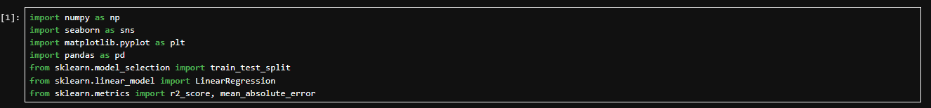

Data Preparation
The necessary Python libraries were imported for the project. NumPy was used for numerical operations, pandas for data manipulation, seaborn and matplotlib for data visualisation, and scikit-learn for model training, evaluation, and preprocessing. These libraries form the foundation of the data analysis and machine learning pipeline.

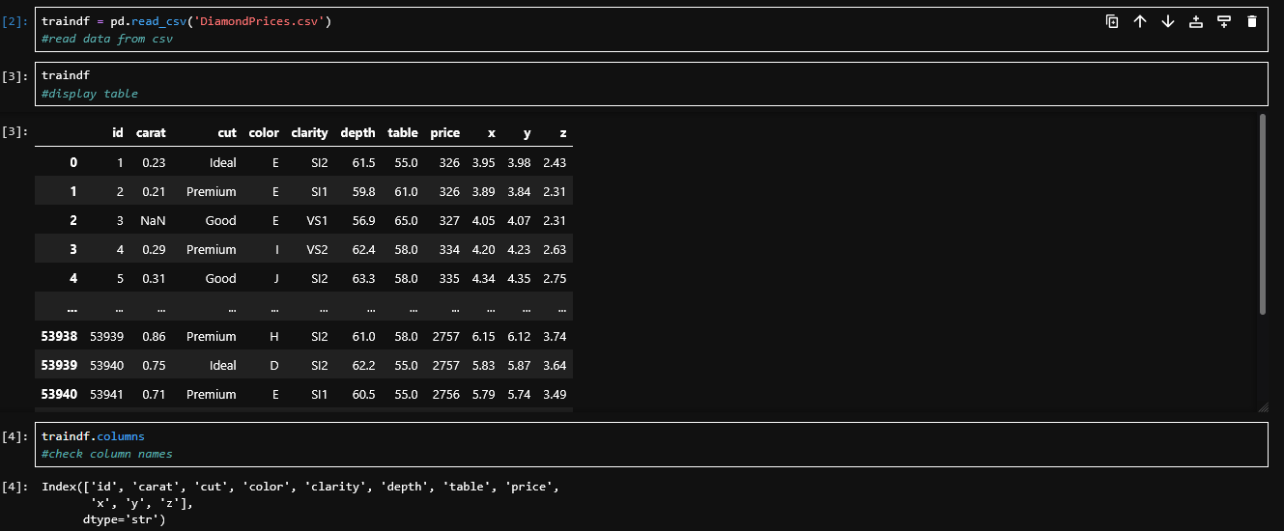
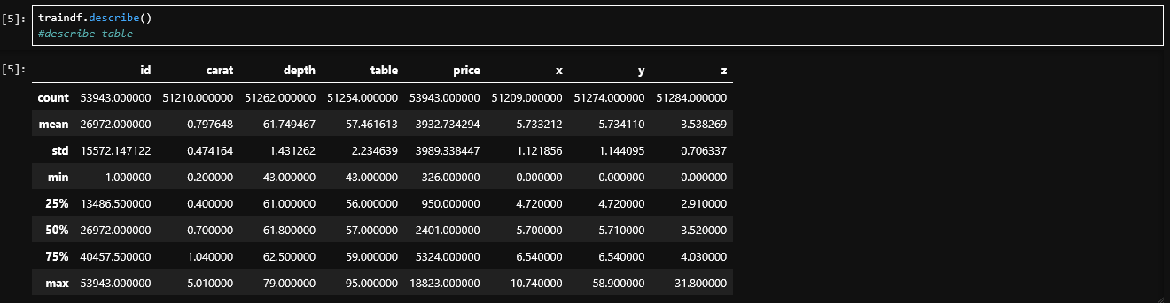The dataset DiamondPrices.csv was loaded into a pandas DataFrame using pd.read_csv() (cell 2). The dataset contains 53,943 rows and 11 columns: id, carat, cut, color, clarity, depth, table, price, x, y, and z. The full table was displayed (cell 3), and column names were checked (cell 4). The target variable is price. The .describe() function (cell 5) revealed that the mean price is approximately $3,932.73 with a standard deviation of $3,989.34, indicating a wide spread in diamond prices. The minimum price is $326. Initial inspection also showed that the carat column has only 51,210 non-null entries out of 53,943 rows, suggesting missing values exist across multiple columns.

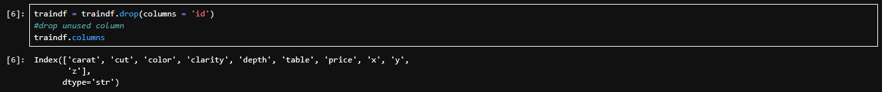The id column was dropped from the dataset as it is a unique row identifier that carries no predictive value. Keeping it would introduce noise and potentially mislead the model during training.

Rows where x, y, or z equal zero were removed. A diamond cannot physically have a dimension of zero, so these entries are treated as data entry errors. Leaving them in would distort the model since zero dimensions do not reflect real diamond measurements.

Outliers in the x, y, and z columns were removed using the 1st and 99th percentile as cutoff thresholds. Values below the 1st percentile or above the 99th percentile were filtered out. This approach was used because extreme outliers can pull the regression line away from the majority of data points and reduce overall model accuracy. The 1%/99% range was chosen to balance between removing genuine outliers and preserving as much usable data as possible.

Duplicate rows were removed using drop_duplicates(keep='first'). This ensures each diamond is represented only once in the dataset. If duplicates were kept, those data points would receive extra weight during model training and bias the results.

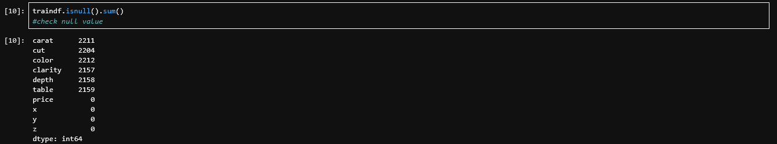A null value check was performed using .isnull().sum(). The results showed that carat has 2,211 missing values, cut has 2,204, color has 2,212, clarity has 2,157, depth has 2,158, and table has 2,159. The price, x, y, and z columns have no missing values. This information was used to plan the imputation strategy for each column.

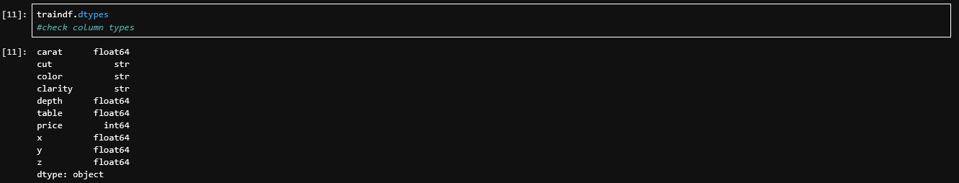The data types of each column were checked using .dtypes. The results showed that carat, depth, table, x, y, and z are float64 (numerical), price is int64 (numerical), and cut, color, and clarity are string/object type (categorical). Since Linear Regression requires all inputs to be numerical, the categorical columns will need to be encoded into numerical form later.

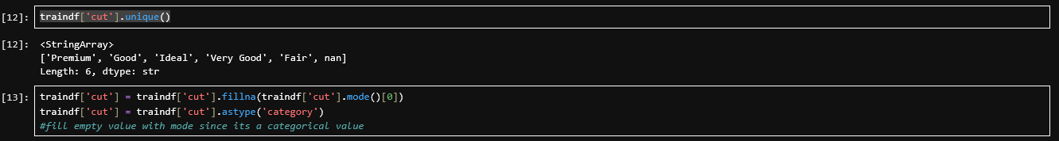The unique values for cut were inspected (cell 12) and found to be: Premium, Good, Ideal, Very Good, Fair, and NaN. Missing values were filled using the mode (the most frequently occurring category) and the column was cast to category type (cell 13). Mode was chosen because cut is a categorical variable — using the mean or median would not make sense for non-numerical data.

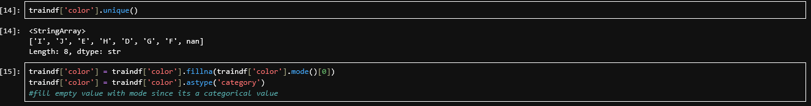The unique values for color were inspected (cell 14) and found to be: I, J, E, H, D, G, F, and NaN. Missing values were filled with the mode and the column was cast to category type (cell 15), following the same reasoning as cut.

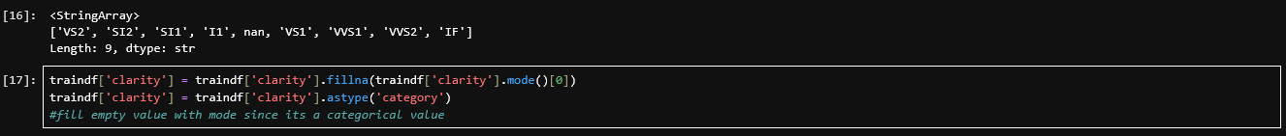The unique values for clarity were inspected (cell 16) and found to be: VS2, SI2, SI1, I1, NaN, VS1, VVS1, VVS2, and IF. Missing values were filled with the mode and the column was cast to category type (cell 17), consistent with the approach for cut and color.

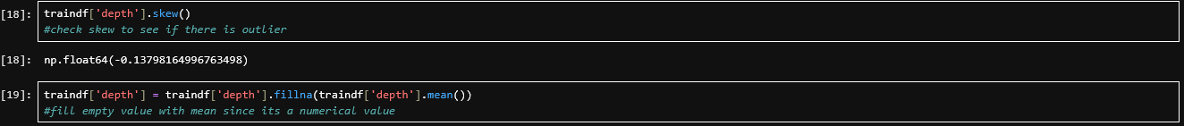The skewness of the depth column was calculated (cell 18) and found to be −0.138, which is very close to zero. This indicates a roughly symmetric distribution. Since the data is not significantly skewed, the mean is an appropriate measure of central tendency, so missing values were filled using the mean (cell 19).

The skewness of the carat column was calculated (cell 20) and found to be 0.774, indicating a moderate positive skew. Missing values were filled using the mean (cell 21). Although the distribution is skewed, the mean was used for imputation and the skewness is addressed later through a log transformation.

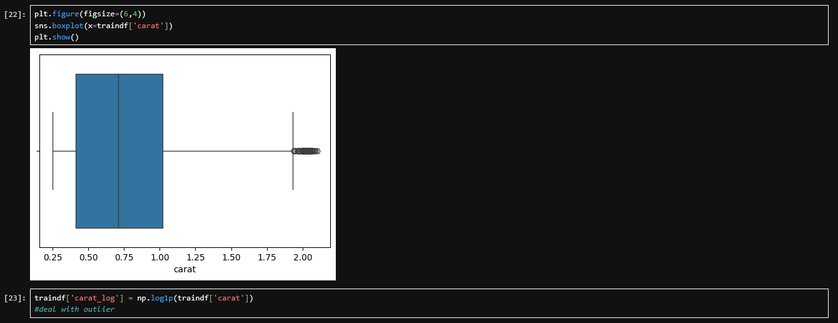

Data Exploration (EDA)
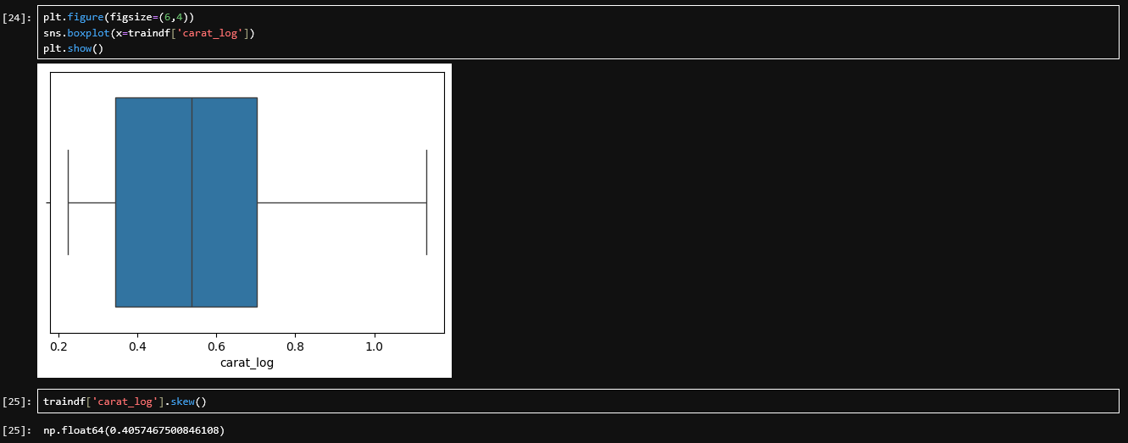A boxplot of the carat column was generated (cell 22), which showed a noticeable right skew with several outliers on the higher end. To address this, the log1p transformation (log of 1 + x) was applied to create a new feature called carat_log (cell 23). A second boxplot was generated after the transformation (cell 24), showing a much more symmetric distribution. The skewness was recalculated (cell 25) and reduced from 0.774 to 0.406, confirming that the transformation successfully compressed the right tail. The carat_log feature is used in place of raw carat for model training.

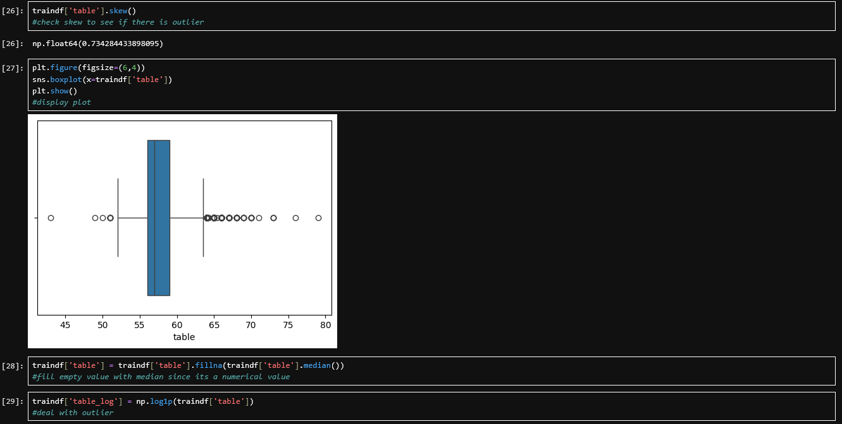The skewness of the table column was calculated (cell 26) and found to be 0.734, indicating a positive skew. A boxplot was generated (cell 27) to visualise the distribution and confirm the presence of outliers. Because the distribution is skewed, the median was used to fill missing values (cell 28) instead of the mean. The median is more robust to skewed data because it is not affected by extreme values the way the mean is.

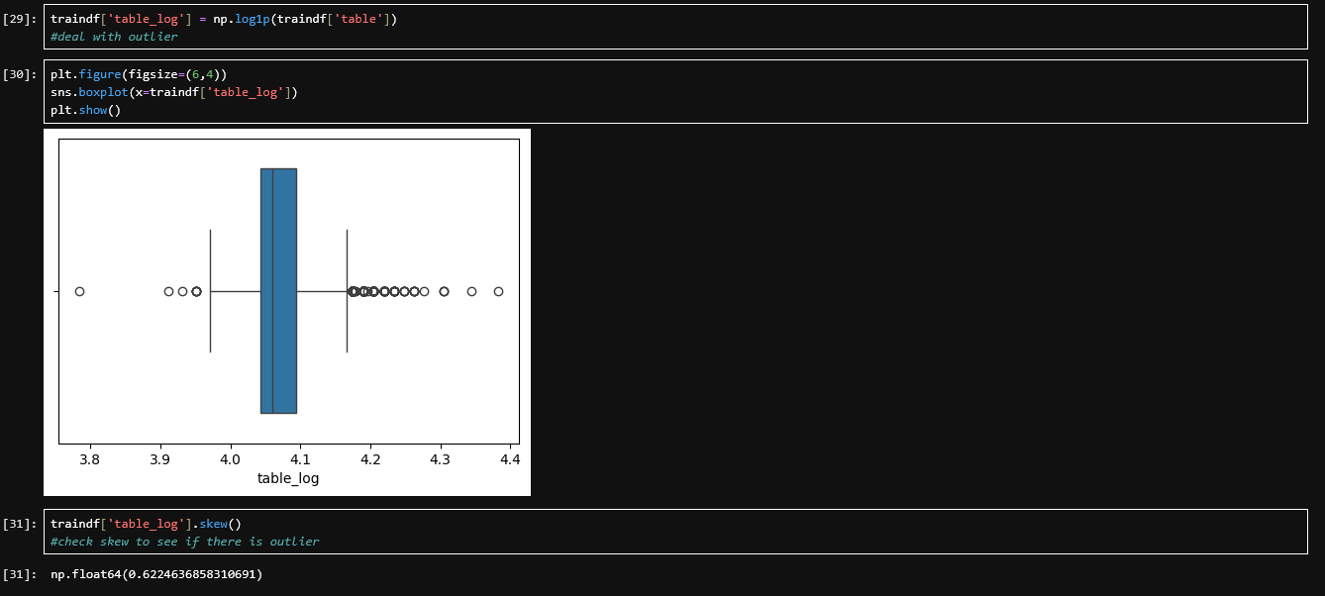The log1p transformation was applied to the table column to create table_log (cell 29). A boxplot after the transformation (cell 30) showed that the distribution became more symmetric. The skewness was recalculated (cell 31) and reduced from 0.734 to 0.622. While still slightly skewed, this is a meaningful improvement that helps the Linear Regression model perform better.

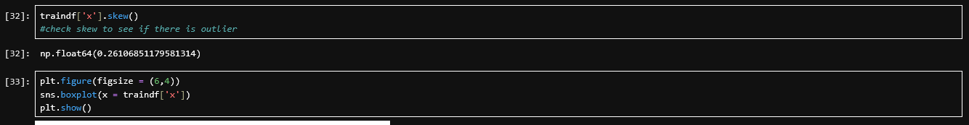The skewness of x was checked (cell 32) and found to be 0.261, which is close to zero and indicates an approximately symmetric distribution. A boxplot (cell 33) confirmed that the data is well-distributed after the earlier percentile-based outlier removal. No further transformation was needed.

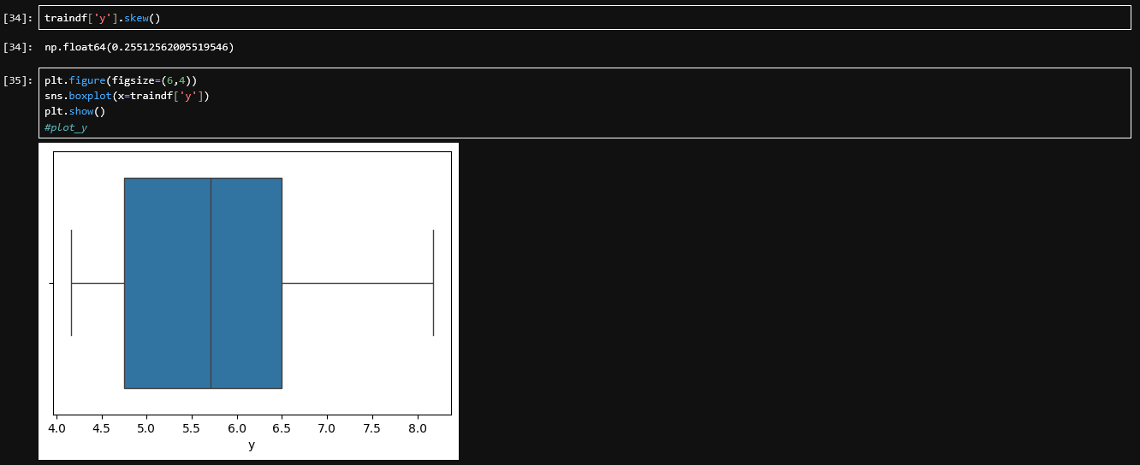The skewness of y was checked (cell 34) and found to be 0.255, also close to zero. A boxplot (cell 35) confirmed a similar well-distributed pattern to x. No further transformation was applied.

The skewness of z was checked and found to be 0.254, consistent with x and y. The distribution is approximately symmetric and no transformation was needed.

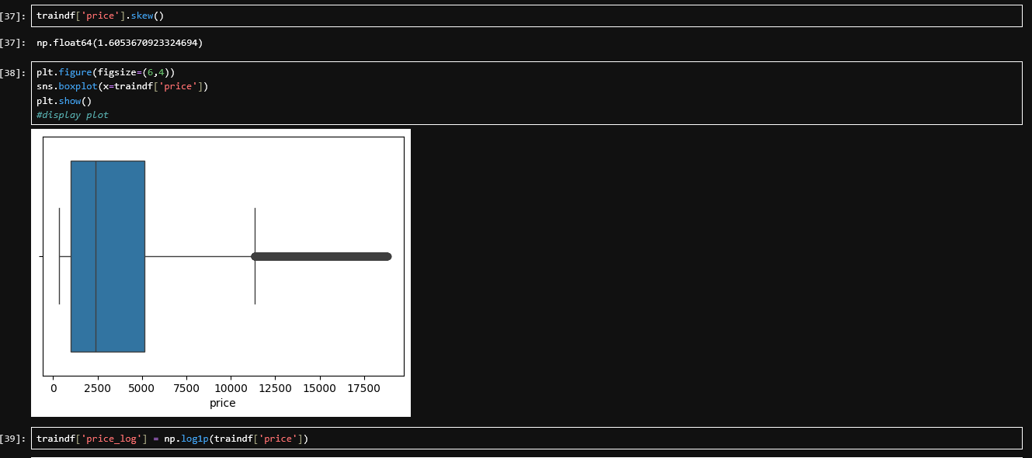
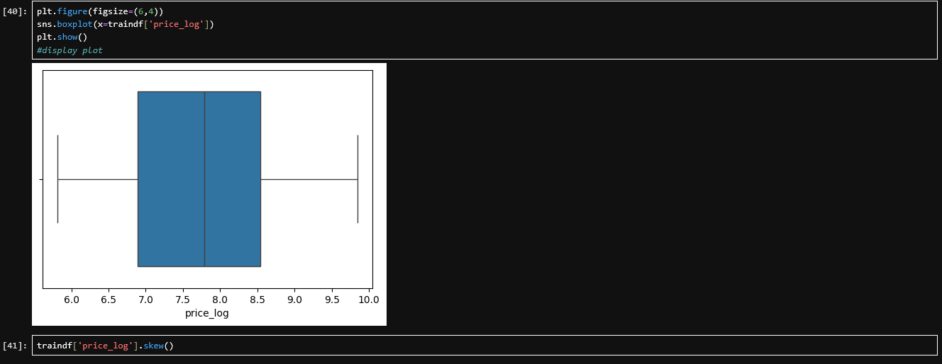The skewness of the price column was calculated (cell 37) and found to be 1.605, indicating a strong positive skew. The boxplot (cell 38) showed that most diamonds are priced at the lower end with a long right tail of expensive diamonds. The log1p transformation was applied to create price_log (cell 39), which becomes the actual target variable for the model instead of raw price. A boxplot after the transformation (cell 40) confirmed a much more symmetric distribution. The skewness was recalculated (cell 41) and dropped dramatically to 0.088, which is nearly symmetric. Predicting log-price with Linear Regression and then converting back to actual price using expm1 tends to produce better results because the relationship between features and log-price is more linear.

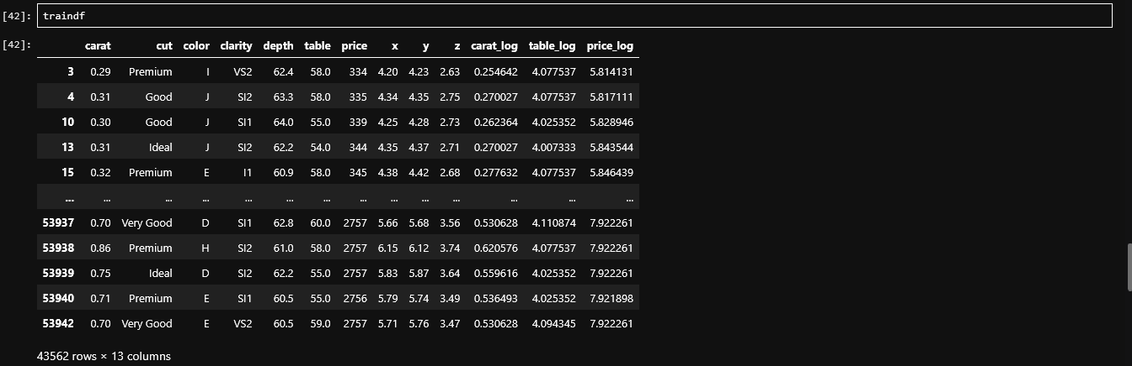The full DataFrame was displayed to visually verify that all transformations and imputations had been applied correctly. The table now includes the original columns along with the newly created carat_log, table_log, and price_log columns.

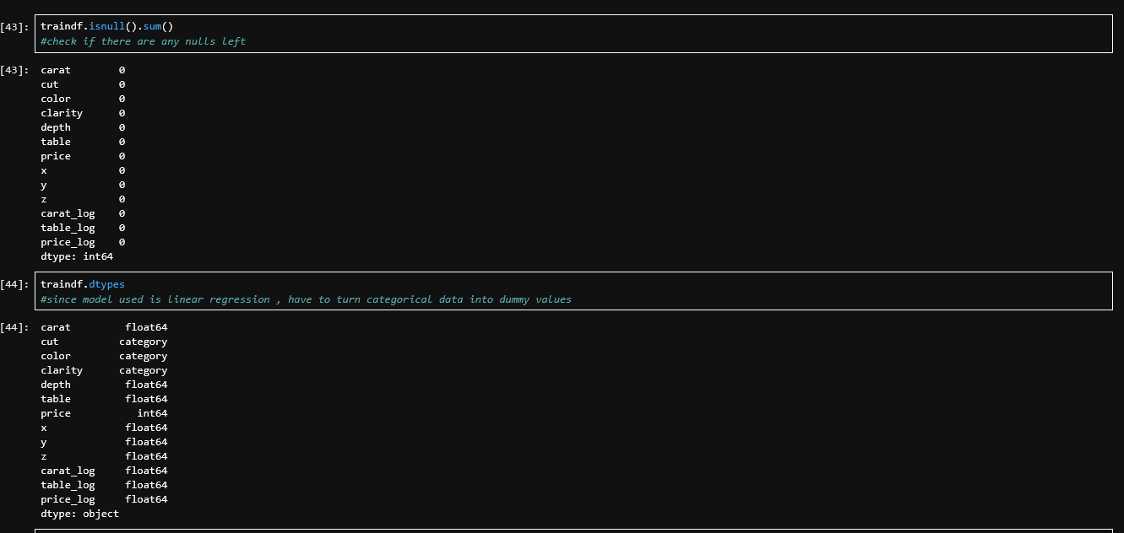A final null check (cell 43) confirmed that all columns now have zero missing values, meaning imputation was successful across all features. The data types were reviewed (cell 44): carat, depth, table, x, y, z, carat_log, table_log, and price_log are all float64, price is int64, and cut, color, and clarity are category type. The data is now fully clean and ready for encoding and modelling.

Train and Test
The categorical columns cut, color, and clarity were converted into binary dummy columns using pd.get_dummies() with drop_first=True. The drop_first=True parameter drops one category from each feature to serve as the reference baseline. This prevents multicollinearity (known as the dummy variable trap), which occurs when one dummy variable can be perfectly predicted from the others. For example, if a diamond is not color E, F, G, H, I, or J, then it must be color D (the dropped reference).

The six numerical features (carat_log, depth, table_log, x, y, z) were placed into one DataFrame (cell 46). This was then concatenated with the dummy-encoded categorical columns to form the complete feature matrix (cell 47). The final feature set contains 23 columns in total.

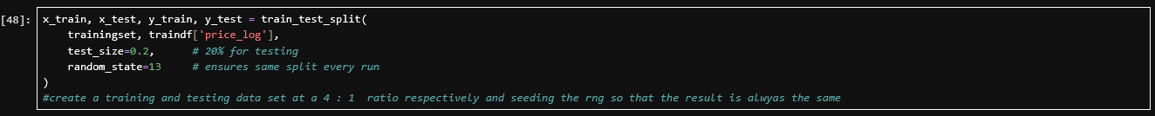The data was split into 80% training and 20% testing using train_test_split. The random_state parameter was set to 13 to seed the random number generator, ensuring that the same split is produced every time the notebook is run. This makes the results reproducible. The target variable is price_log, not raw price, because the log-transformed target was shown in the EDA section to have a much more symmetric distribution.

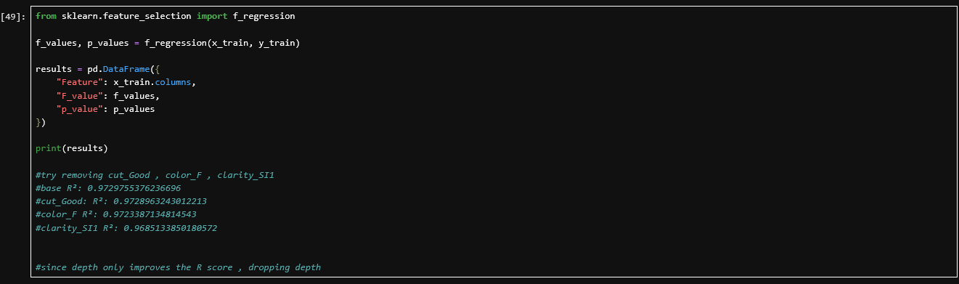The f_regression function was used to evaluate the linear relationship between each feature and the target variable. This test produces an F-statistic and a p-value for each feature. A low p-value indicates a statistically significant relationship. The results showed that carat_log, x, y, and z had extremely high F-values and p-values of 0.0, meaning they are very strong predictors. Features such as color_G and color_F had higher p-values, indicating weaker linear relationships with price.

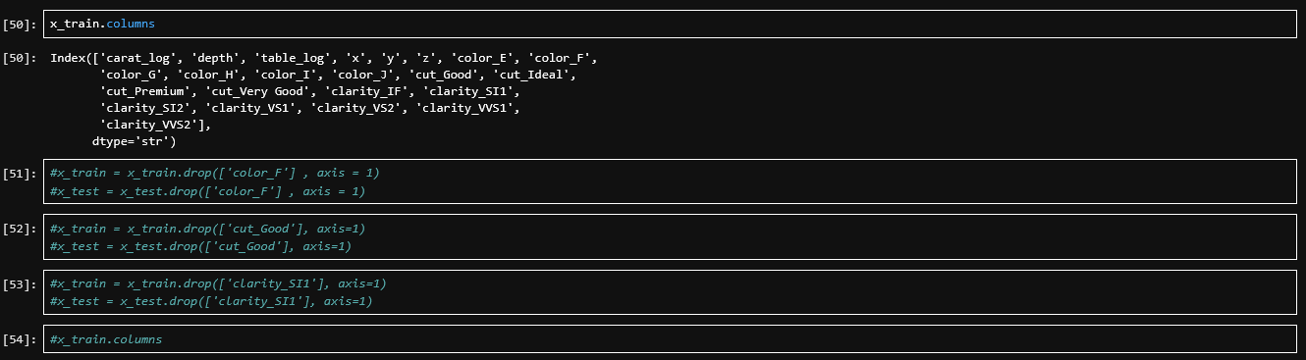The training columns were inspected (cell 50) to review all 23 features. Cells 51, 52, and 53 contain commented-out code that tested whether removing color_F, cut_Good, and clarity_SI1 (the features with the weakest p-values) would improve model performance. Cell 54 is a commented-out column check. After testing, these removals did not improve the R² score, so the code was left commented out and all 23 features were retained in the final model.

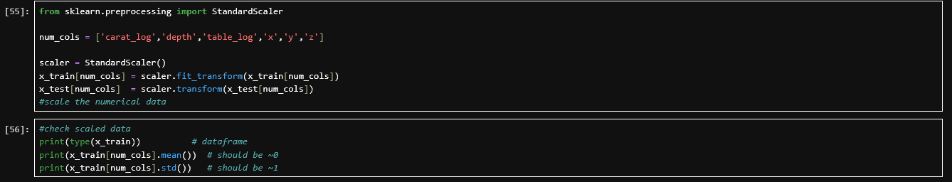StandardScaler was applied to the six numerical columns: carat_log, depth, table_log, x, y, and z (cell 55). This transforms each feature to have a mean of approximately 0 and a standard deviation of approximately 1. Scaling is necessary because features like depth and carat_log have different ranges and magnitudes — without scaling, features with larger values would dominate the regression coefficients. The scaler was fitted on the training data only using fit_transform, and then the test data was scaled using transform alone. This prevents data leakage, where information from the test set would influence the training process. The verification (cell 56) confirmed that all scaled training features have a mean very close to 0 and a standard deviation of approximately 1.

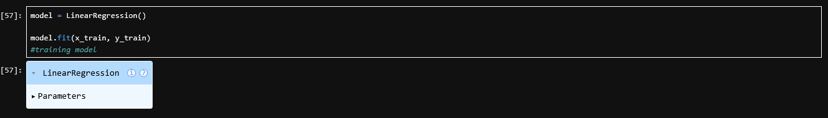A Linear Regression model was instantiated and trained on the scaled training features with price_log as the target variable. The model learns a coefficient (weight) for each of the 23 features that minimises the sum of squared differences between the predicted and actual log-prices.

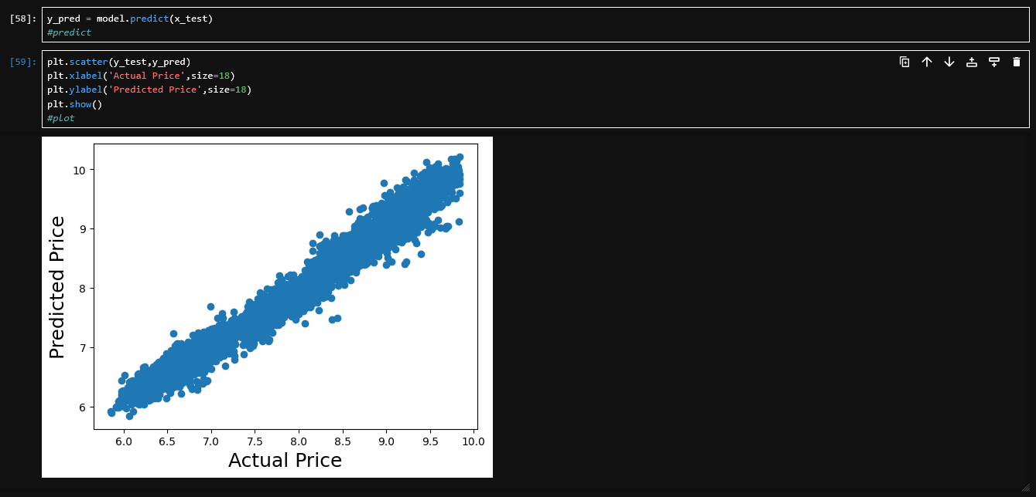The trained model was used to predict price_log values on the test set (cell 58). A scatter plot of actual versus predicted values was generated (cell 59). The points cluster tightly along a diagonal line, indicating that the model's predictions closely match the actual values. There is minimal scatter, which suggests the model captures the underlying relationship between diamond features and price well.

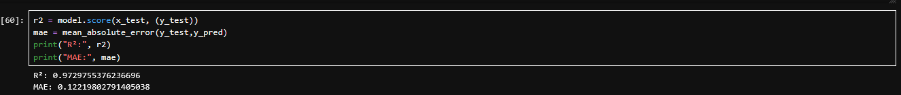The model was evaluated using two metrics. The R² score is 0.9730, meaning the model explains approximately 97.30% of the variance in log-price. This is a strong result indicating an excellent fit. The Mean Absolute Error (MAE) is 0.1222 in log-price units, meaning that on average the model's predictions deviate from the actual log-price by only 0.1222 units. Both metrics indicate that the Linear Regression model performs well on the test set.

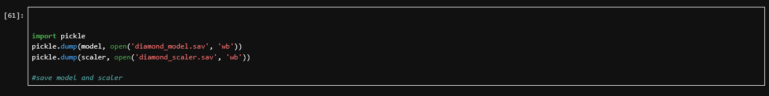The trained model was saved to diamond_model.sav and the fitted scaler was saved to diamond_scaler.sav using the pickle library. Saving both artifacts allows Phase 2 to load and reuse them without retraining. This ensures that the prediction pipeline in Phase 2 uses the exact same model weights and scaling parameters that were learned during training.

Phase 2

Objective
- To apply the trained predictive model onto a new diamond dataset to validate and confirm the accuracy of the predicted diamond prices.

Modelling and Deployment
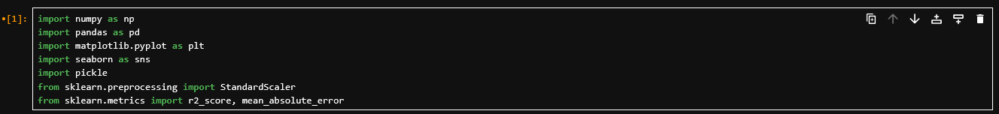The necessary Python libraries were imported: NumPy, pandas, matplotlib, seaborn, pickle for loading saved files, and StandardScaler, r2_score, and mean_absolute_error from scikit-learn for scaling and evaluation.

The saved Linear Regression model and StandardScaler from Phase 1 were loaded into memory using pickle. This ensures that the exact same trained model and scaling parameters are used for prediction, maintaining full consistency with the training pipeline.

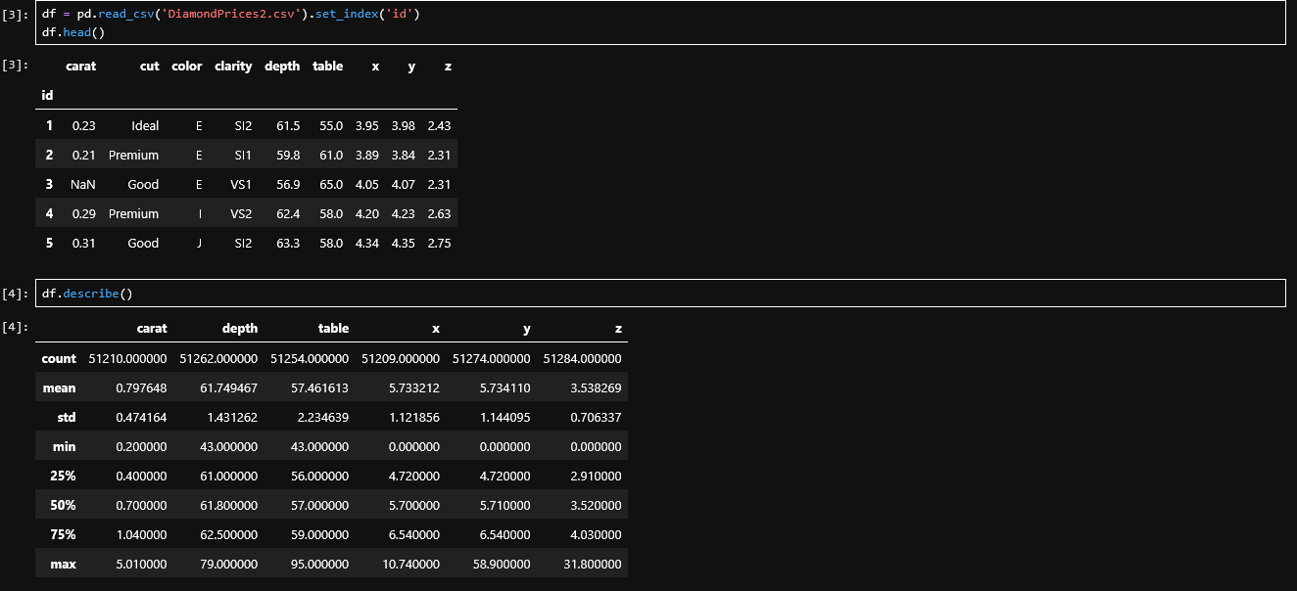
The new dataset DiamondPrices2.csv was loaded with the id column set as the index (cell 3), as it is needed later for alignment with actual prices. The .describe() function (cell 4) showed similar distributions to the Phase 1 data, with a mean carat of approximately 0.798 and similar ranges for depth and table. The column names were confirmed (cell 5) to match the expected features: carat, cut, color, clarity, depth, table, x, y, and z.

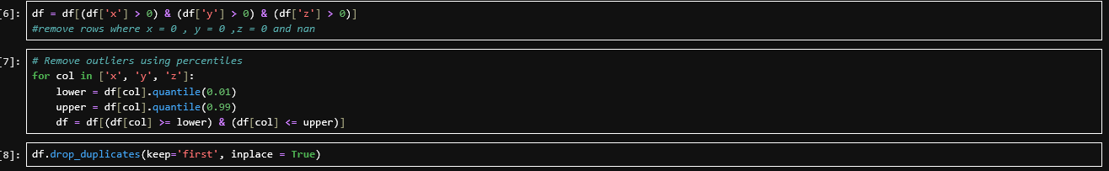The same data cleaning steps from Phase 1 were applied to ensure consistency. Rows where x, y, or z equal zero were removed (cell 6). Outliers in x, y, and z were filtered using the 1st and 99th percentile thresholds (cell 7). Duplicate rows were dropped (cell 8). It is essential that the new data undergoes the same cleaning process because the model was trained on data prepared this way. Applying different cleaning logic could introduce inconsistencies and reduce prediction accuracy.

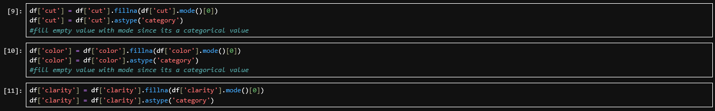Missing values in cut (cell 9), color (cell 10), and clarity (cell 11) were filled using the mode (most frequent value) of each column in the new dataset, and each column was cast to category type. This follows the same imputation strategy used in Phase 1 to maintain consistency in how missing categorical data is handled.

Missing values in depth were filled with the mean (cell 12) and missing values in carat were filled with the mean (cell 13), matching the Phase 1 imputation strategy for these numerical columns.

The log1p transformation was applied to the carat column to create carat_log, the same transformation used in Phase 1. This ensures the feature is on the same scale and distribution the model was trained to expect.

Missing values in the table column were filled with the median, consistent with Phase 1. The log1p transformation was then applied to create table_log.

The categorical columns color, cut, and clarity were converted into binary dummy columns using pd.get_dummies() with drop_first=True, consistent with Phase 1. The dummy values were cast to integer type. The expected column names from the model were also retrieved using model.feature_names_in_ to prepare for column alignment in a later step.

The six numerical features (carat_log, depth, table_log, x, y, z) were selected into a separate DataFrame (cell 17). These were then scaled using the saved scaler from Phase 1 with .transform() (cell 18). Importantly, .transform() was used instead of .fit_transform(). This is critical because fitting a new scaler on the new data would calculate different mean and standard deviation values, which would make the model's learned coefficients meaningless. By using the Phase 1 scaler, the new data is transformed on the same scale the model was trained on.

The scaled numerical features and the dummy-encoded categorical features were concatenated into a single DataFrame. The .reindex() function was then used with columns=model.feature_names_in_ and fill_value=0 to ensure that the columns match exactly what the model expects. If a category that existed in the training data does not appear in the new data, its column is filled with 0. If the new data contains a category that was not present during training, it is excluded. This alignment step prevents errors during prediction.

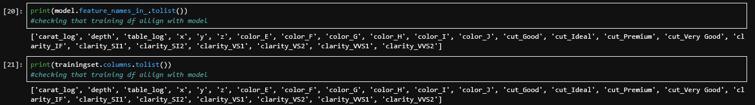
The model's expected feature names (cell 20) and the actual column names of the prepared dataset (cell 21) were printed and compared. Both lists contain the same 23 features in the same order: carat_log, depth, table_log, x, y, z, color_E, color_F, color_G, color_H, color_I, color_J, cut_Good, cut_Ideal, cut_Premium, cut_Very Good, clarity_IF, clarity_SI1, clarity_SI2, clarity_VS1, clarity_VS2, clarity_VVS1, and clarity_VVS2. This confirms the data is correctly aligned and ready for prediction.

The model was used to predict log-price values for all diamonds in the new dataset. The np.expm1() function was then applied to reverse the log1p transformation, converting the predicted log-prices back into actual dollar values. The results were stored in a new DataFrame with a PredictedPrice column.

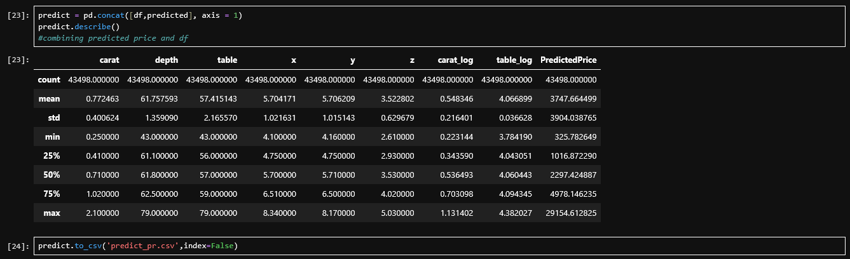The predicted prices were joined with the original diamond features so that each row displays the diamond's physical attributes alongside its predicted price (cell 23). The .describe() function summarised the predictions, showing the mean, min, max, and quartile values of the predicted prices. The combined dataset was then exported to predict_pr.csv (cell 24) for delivery and further analysis.

Evaluation
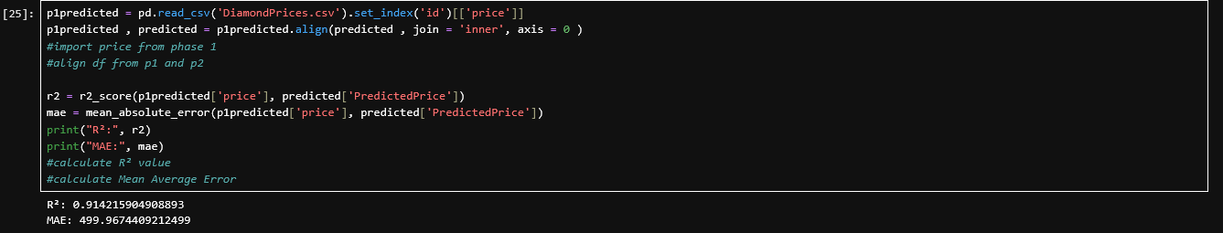To validate the model's performance on new data, the actual prices from DiamondPrices.csv were imported and aligned with the predicted prices using the shared id index through an inner join. Only diamonds present in both datasets were compared. The R² score on the new data is 0.9142, meaning the model explains approximately 91.42% of the variance in actual diamond prices. The MAE is $499.97, meaning on average the predicted price differs from the actual price by approximately $500. Compared to the Phase 1 test set R² of 0.9730, there is a slight drop, which is expected when applying a model to new data. However, an R² of 0.9142 still indicates strong predictive performance, confirming that the model generalises well beyond the training set.

- Each group is required to make an evaluation of the assignment he / she embarked on. The assignment evaluation may include:
- Evaluation of assignment (Each Student must write their own evaluations)
  - Students’ view on the strengths and weaknesses of the work done.
- Personal reflection (Each Student must write their own reflections)
  - Students are required to describe the various problems faced by students in the course of doing the assignment and explain what has been done to solve the problems, the valuable experiences gained or lessons learnt through the assignment as a whole.

Evaluation of assignments

References

Appendix

